**CHAPTER :- 1**

**Industry Introductions**

**1.1 Company Profile**

**Technomads Solution Pvt. Ltd.**

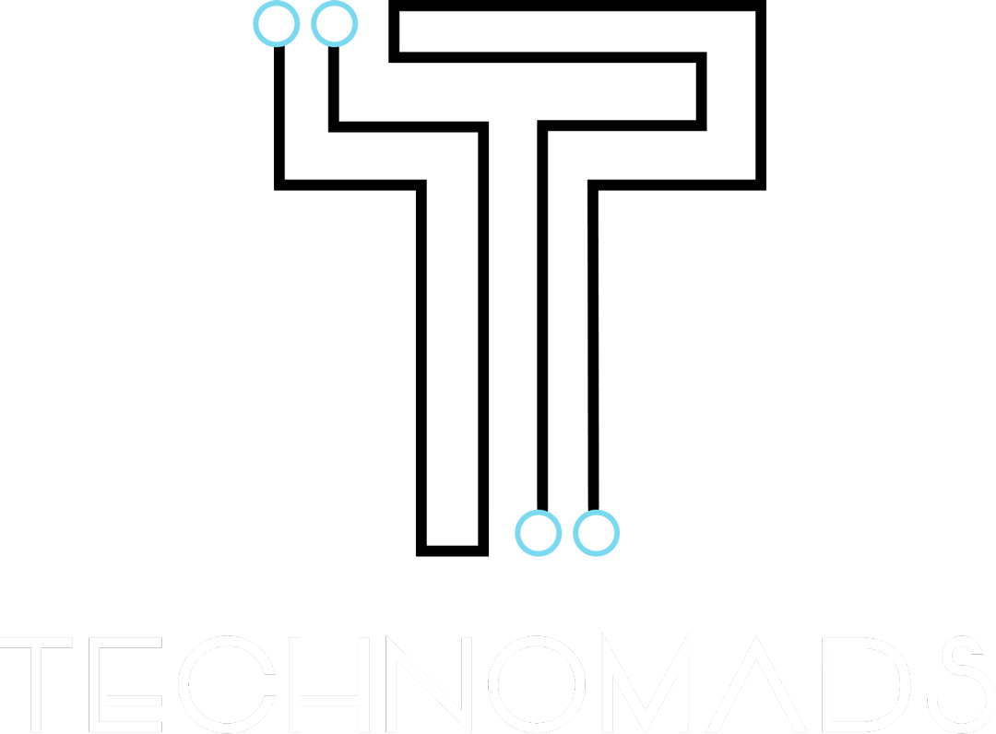

**Contact Information:-**

Phone:- [+91 63549 53278](tel:+91%2063549%2053278)

E-Mail:- [info@technomads.in](mailto:info@technomads.in)

Address:- 4080, Silver Business Point VIP Circle Utran Surat, Gujarat 394105

**What the Company Does?**

The company helps organizations streamline their efforts by providing customer-specific technical solutions. Their proven methodologies have helped their clients increase both internal efficiencies and revenue. They have helped businesses to build an online presence which opens the door to more sales and more growth of their business. They help their clients reach more customers with less money spend than the traditional marketing methods.

**What the Company has Achieved:**

Two 24 years old young entrepreneurs started their journey to build a great company after quitting their 9 to 5 job. TechNomads started their operations in July, 2019 in Surat and in a shortest span of time they have gained trust of local clients as well as international clients from Australia. They are building products in the healthcare industry and they believe the greatest products or solutions solve the simplest problems.

**Services provided by the Company:**

The company provides various services. Their work includes but is not limited to projects built using Blockchain, NodeJS, ReactJS, Flutter, and they also make Android App, iOS App, and apps for other platforms.

**Their Social media presence:**

Website:- https://technomads.in

Facebook:- https://www.facebook.com/technomadss

Twitter:- https://twitter.com/technomadss

LinkedIn:- https://www.linkedin.com/company/tech-nomads/mycompany

**CHAPTER: - 2**

**Introduction of project**

**2.1 Introduction of Problem**

**2.1.1 Problem statement**

* Maintenance fees. Payments-related concerns include mode of payment, timely submission of fees, etc. So we provide the perfect solution for all the above matters for instance payments mode includes online payment, UPI along with cash notes. Also, our system will provide a timely reminder to everyone for submission of maintenance fees through text message.
* Voting for various events is important in urban areas. In our system, we have included a voting system for various events.
* In residential areas, there is a lack of communication between people because of a daily busy life. The solution is for society members can communicate with each other through the chats module.
* Society members can complain about day-to-day issues in residential areas. As well as members can suggest new ideas to improve residential area facilities.
* Members can see the notice of various events, meetings, etc. which can be added by the admin.

**2.1.2 Scope of proposed system:**

* Our project is a smart and technology-forward security solution that helps you manage gated community security needs like entry and exit of visitors, household help, and online delivery personnel. It also helps in managing gated community needs like clubhouse and amenities management, complaint management, accounting and billing, and more.
* So to solve this problem there are many Security management services that are recognized and ensure the protection of resources and practices of an organization, person, or any group.
* Occupants can utilize the our application to speak with neighbours, examine matters of the local area and society on inward conversation gatherings, manage guests (visitors, conveyances, taxis, and so on), maintain participation record, and compensation installments for day by day help, find services, take care of society maintenance bills, among much else.
* In our project user can add location based emergency alerts.
* People who cannot help will not be bothered.
* On-Device database for Offline access.
* Paid plan for larger societies.

**2.2 Environment Description**

**2.2.1 Hardware and Software Requirements:**

**Minimum**

**Windows**

* Hardware
  + Processor: Dual code, 1GHz
  + RAM: 4GB
  + Storage: 2GB free
  + Display: 720p or higher
* Software
  + Windows 7 or higher

**macOS**

* Hardware
  + Processor: Dual code, 1.8GHz
  + RAM: 4GB
  + Storage: 2GB free
  + Display: 720p or higher
* Software
  + macOS El Capitan (macOS 10.11) or higher

**Linux**

* Hardware
  + Processor: Dual code, 1GHz
  + RAM: 4GB
  + Storage: 2GB free
  + Display: 720p or higher
* Software
  + Debian based Linux distribution

**Android**

* Hardware
  + Processor: 1GHz
  + RAM: 1GB
  + Storage: 2GB free
  + Display: 720p or higher
* Software
  + Android Jelly Bean (4.1) or higher

**iOS**

* Hardware
  + Storage: 2GB free
* Software
  + iOS 9 or higher

**Recommended**

**Windows**

* Hardware
  + Processor: Dual code, 2.3GHz
  + RAM: 8GB
  + Storage: 2GB free
  + Display: 1080p or higher
* Software
  + Windows 10 or higher

**macOS**

* Hardware
  + Processor: Dual code, 1.8GHz
  + RAM: 8GB
  + Storage: 2GB free
  + Display: 1080p or higher
* Software
  + macOS Monterey (macOS 12) or higher

**Linux**

* Hardware
  + Processor: Dual code
  + RAM: 8GB
  + Storage: 2GB free
  + Display: 1080p or higher
* Software
  + Debian based Linux distribution

**Android**

* Hardware
  + Processor: modern multicore processor
  + RAM: 4GB
  + Storage: 2GB free
  + Display: 1080p or higher
* Software
  + Android KitKat (4.4) or higher

**iOS**

* Hardware
  + Processor: Apple A9 or higher
  + RAM: 2GB
  + Storage: 2GB free
* Software
  + iOS 14 or higher

**2.1.2 Technology Used**

**Flutter:**

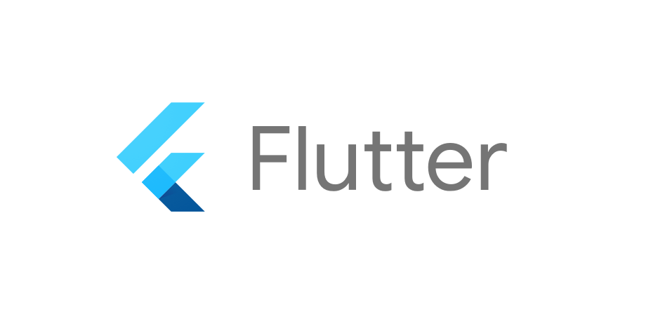

* Flutter is a tool that allows developers to build native cross-platform apps with just one programming language and also one codebase. It will not create an app that runs in the browser or something that gets wrapped by native apps. Instead, it creates a native app for both iOS and Android that can be published to the stores later.
* The good news is that you can create this app just by using one programming language, rather than using separate ones to build an iOS app or an Android app. That way, you will have just one code base to worry about. Flutter is an SDK (Software Development Kit) that allows you to compile your codebase into native machine code that runs on the platforms mentioned above.
* Besides its compilation tools, Flutter acts as a framework by providing a collection of UI building blocks (widgets) like tabs, dropdowns, buttons, etc., some utility functions; and some packages that will get compiled by using the SDK.

**Dart:**

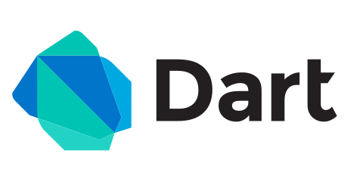

* Dart is the open-source programming language originally developed by Google. It is meant for both server side as well as the user side. The Dart SDK comes with its compiler – the **Dart VM** and a utility dart2js which is meant for generating **Javascript equivalent of a Dart Script** so that it can be run on those sites also which don’t support Dart.
* Dart is **Object-oriented language** and is quite similar to that of [**Java Programming**](https://www.geeksforgeeks.org/java/).
* Dart is extensively use to create single-page websites and web-applications. Best **example** of dart application is **Gmail**.

**GitHub:**

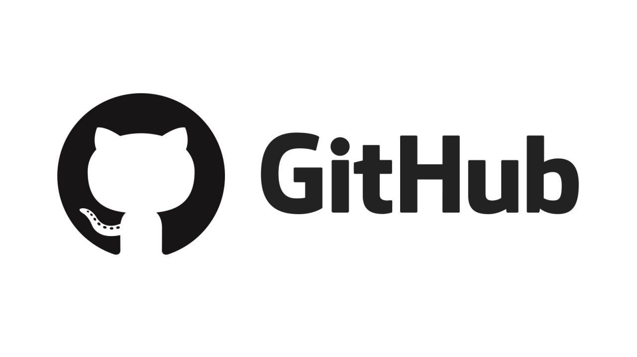

* Github is a web-based interface that uses Git, the open source version control software that lets multiple people make separate changes to web pages at the same time. As Carpenter notes, because it allows for real-time collaboration, GitHub encourages teams to work together to build and edit their site content.
* GitHub allows multiple developers to work on a single project at the same time, reduces the risk of duplicative or conflicting work, and can help decrease production time. With GitHub, developers can build code, track changes, and innovate solutions to problems that might arise during the site development process simultaneously. Non-developers can also use it to create, edit, and update website content, which Carpenter demonstrates in her tutorial.

**Firebase:**

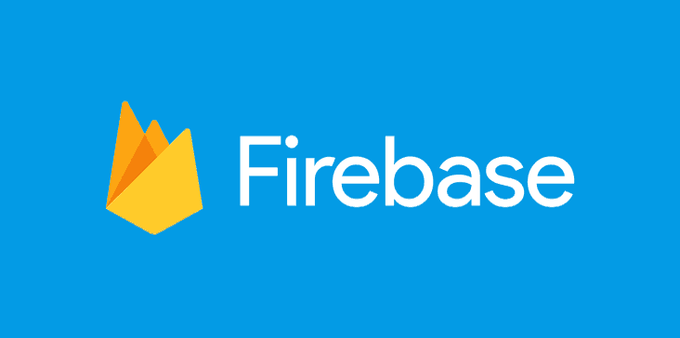

* Firebase File System is an Android Application that allows the android users to store the files in the cloud tool called Firebase. It also lets users to share the files with each other. The app permits users to share the files in a secure way. In order to securely share the files with the other users Google Authentication is integrated to the app for eliminating unauthorized access. Some of the other features that are implemented in this app are, creating groups, granting access permissions for the directories and files by the group owner or by the Owner of the file, uploading and downloading of the files by the users who are granted with write access (W), viewing and downloading of the files by the users who have read with download access (D) and inspecting the files/directories, if the users have read only access (R).